**Umkehr Effect**

**What is the Umkehr Effect?**

As the reader may be aware, the Dobson ozone spectrophotometer functions by comparing two wavelengths of scattered ultraviolet light, where one of the wavelengths is strongly absorbed by ozone. So, in this first piece of theory that we will discuss, the Umkehr Effect, we are doing exactly that.

The way in which we usually compare the intensity of two ultraviolet wavelengths is using the N-value:

N = log(I’/I) +K

Where I is the intensity of the shorter (and more strongly absorbed) wavelength and I’ is conversely the intensity of the longer (and less strongly absorbed) wavelength and K is a constant. We will revisit this equation later when we discuss turning the R-dial readings of the Dobson into ozone values.

When measuring the N value for a wavelength pair (in this case the wavelength pair known as “C”), we notice a change with the solar zenith angle:

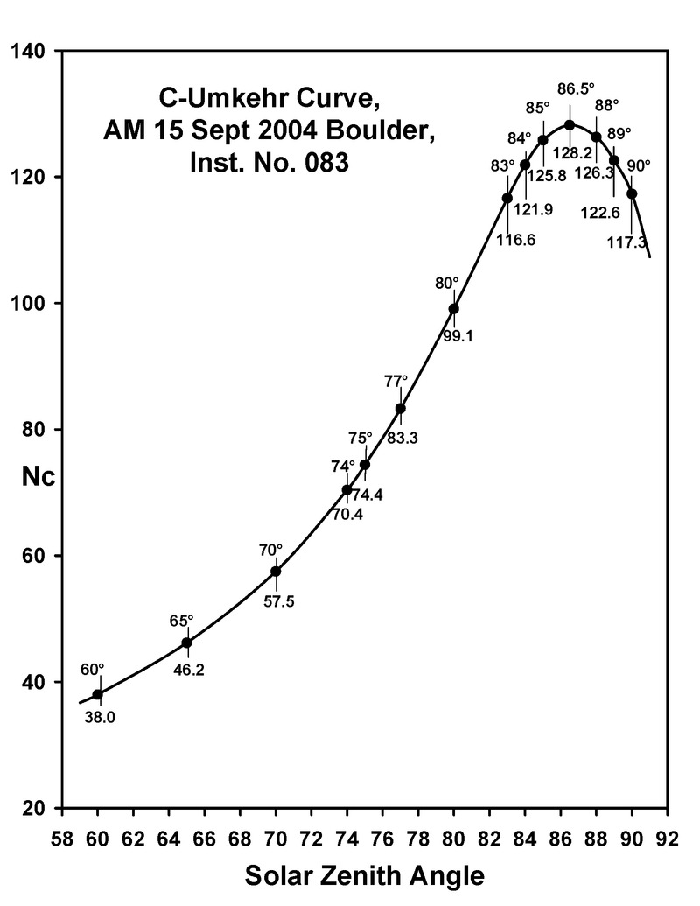

*N.B. The solar zenith angle is the angle made between solar zenith (i.e. the point directly above an observer) and the sun. E.g. the sun at sunset has a solar zenith angle of 90 degrees and the sun at noon on the tropic of cancer on the June solstice has an SZA of zero.*

From Fig 1, we see that the log ratio of the two wavelengths increases, until it reaches a maximum near sunset, then it begins to decrease. This reversal is where the term “umkehr” comes from, as it is German for “reversal”. In the context of ozone, this increase, maximum and decrease is what we are referring to when we use the term umkehr.

**What causes the Umkehr Effect?**

The Umkehr Effect is caused by differences in scattering as the angle of the sun with respect to the observer changes throughout the day. To illustrate how the scattering effects change through the day, we will first think about a very low Solar Zenith Angle.

Near the top of the atmosphere, there are far fewer particles to scatter off as the air is less dense, so as the Sun’s rays progress through the atmosphere and the density of air increases, the likelihood of a scattering occurring increases. Therefore when the sun is very high in the sky, the majority of the scattered light received will be from the lower part of the atmosphere. Also, when the sun is high in the sky, the path length through the atmosphere is at a minimum, so atmospheric extinction of sunlight and absorption by ozone will also be at a minimum.

Now let us consider the sun at a very high zenith angle, near sunrise or sunset. We consider the sun to be sufficiently far away that the sun’s rays are parallel. And when the sun is near the horizon, the sun’s rays will be parallel to the ground. Therefore we have some of the rays travelling low in the atmosphere and some of the rays are travelling near the top of the atmosphere. The rays near the bottom of the atmosphere will encounter far more air than at the top and so there will be greater extinction in this part, therefore the lower atmosphere will contribute far less light than in the previous example. It must then be concluded that the average height of scattering is higher in the atmosphere when the sun is low in the sky.

Taking the above arguments to their conclusion, it can be shown that the average height of scattering gradually increases as the Solar Zenith Angle increases. We can create a term for the average height of scattering – Effective Scattering Height. In a simplified model, we consider all scattering to occur at this height and much progress has been made by using this simplified model. However, the reality is there is a spectrum of heights at which scattering occurs, *the peak of which is at the Effective Scattering Height*.

The Effective Scattering Height, is dependent on a number of factors for a certain wavelength. We have discussed the effect of the Solar Zenith Angle, but the Effective Scattering Height also depends on the ozone absorption coefficient for that wavelength, α. The ozone absorption coefficient for the shorter wavelength of any of the three primary wavelength pairs used for the Dobson is always higher than for the longer, as the shorter wavelength is always more strongly absorbed. As a result, the Effective Scattering Height for the shorter wavelength will always be higher than for the long wavelength. The shorter wavelength will suffer a deficit of light scattered in the ozone layer as some of the light will have been absorbed from here, therefore a greater proportion of the total light will come from above the ozone layer. This can be seen by comparing the 70 and 77 degree source functions for the short and long wavelengths in the figure below.

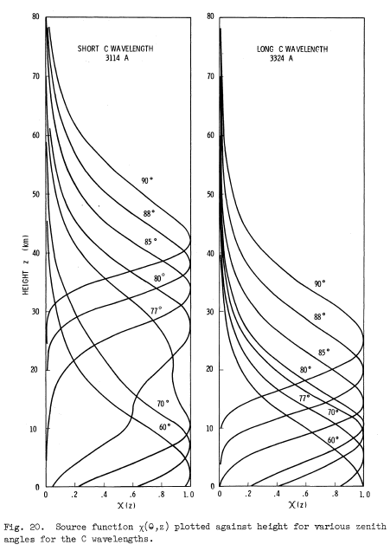

Now we have the tools we need to understand the Umkehr effect. The amount of light from both wavelengths decreases as the Solar Zenith Angle increases, however the shorter wavelength decreases faster – up until the point where the Effective Scattering Height is in the ozone layer. When the ESH reaches a point above the ozone layer the amount of light from the shorter wavelength decreases more slowly.